***ARTIFICIALL INTELLIGENCE IN FLIGHTS***

To pass muster, AI would need to prove itself virtually foolproof. “What you don’t want to have is the system to fail in a very unusual way and say, ‘I give up, I’ll just transfer control back over to the human.’ And then a human won’t know how to recover,” Kochenderfer says.

As we all know that Autopilots on airliners fly through turbulence every day using ARTIFICIALL INTELLIGENCE. Researchers did not preprogram the code in the system with the aerodynamic model of the plane that would normally define how the autopilot should change thrust. Instead, researchers designed the software to rapidly figure out how to make the aircraft execute the appropriate pitch, roll and yaw maneuvers. This software was developed under a NASA aeronautics initiative called Learn-to-Fly. Before flying public will entrust their lives to completely automated aircraft in which artificial intelligence software that might utilize Learn-to-Fly code.  When some emergency situation occurs, to cope with them it plays out in three dimensions -numerous flight control surfaces involved, a range of ambient conditions and data arriving from multiple sensors. This AI software recognizes when sensor readings are incorrect. Then software would need to make the right decision in a situation that might never have arisen before, and AI designers and flight regulators would need to be assured that it would make the right decision.

The main issue driving the improvement of the AI in the flying promote fuse the use

of gigantic data in the flying exchange, critical addition in capital hypotheses by flying associations, and

rising gathering of cloud-based applications and organizations in the flight business

The main issue driving the improvement of the AI in the flying promote fuse the use

of gigantic data in the flying exchange, critical addition in capital hypotheses by flying associations, and

rising gathering of cloud-based applications and organizations in the flight business

The main issue driving the improvement of the AI in the flying promote fuse the use

of gigantic data in the flying exchange, critical addition in capital hypotheses by flying associations, and

rising gathering of cloud-based applications and organizations in the flight business

The main issue driving the improvement of the AI in the flying promote fuse the use

of gigantic data in the flying exchange, critical addition in capital hypotheses by flying associations, and

rising gathering of cloud-based applications and organizations in the flight business

The main issue driving the improvement of the AI in the flying promote fuse the use

of gigantic data in the flying exchange, critical addition in capital hypotheses by flying associations, and

rising gathering of cloud-based applications and organizations in the flight business

The main issue driving the improvement of the AI in the flying promote fuse the use

of gigantic data in the flying exchange, critical addition in capital hypotheses by flying associations, and

rising gathering of cloud-based applications and organizations in the flight business

The main issue driving the improvement of the AI in the flying promote fuse the use

of gigantic data in the flying exchange, critical addition in capital hypotheses by flying associations, and

rising gathering of cloud-based applications and organizations in the flight business

The main issue driving the improvement of the AI in the flying promote fuse the use

of gigantic data in the flying exchange, critical addition in capital hypotheses by flying associations, and

rising gathering of cloud-based applications and organizations in the flight business

The main issue driving the improvement of the AI in the flying promote fuse the use

of gigantic data in the flying exchange, critical addition in capital hypotheses by flying associations, and

rising gathering of cloud-based applications and organizations in the flight businessThe main issue driving the improvement of the AI in the flying promote fuse the use of gigantic data in the flying exchange, critical addition in capital hypotheses by flying associations, and rising gathering of cloud-based applications and organizations in the flight business.

And one more interesting thing is that Joined Airlines has tied up with Amazon Alexa to enable clients to check in and find out about their flights. Can we think that this happens because of AL?

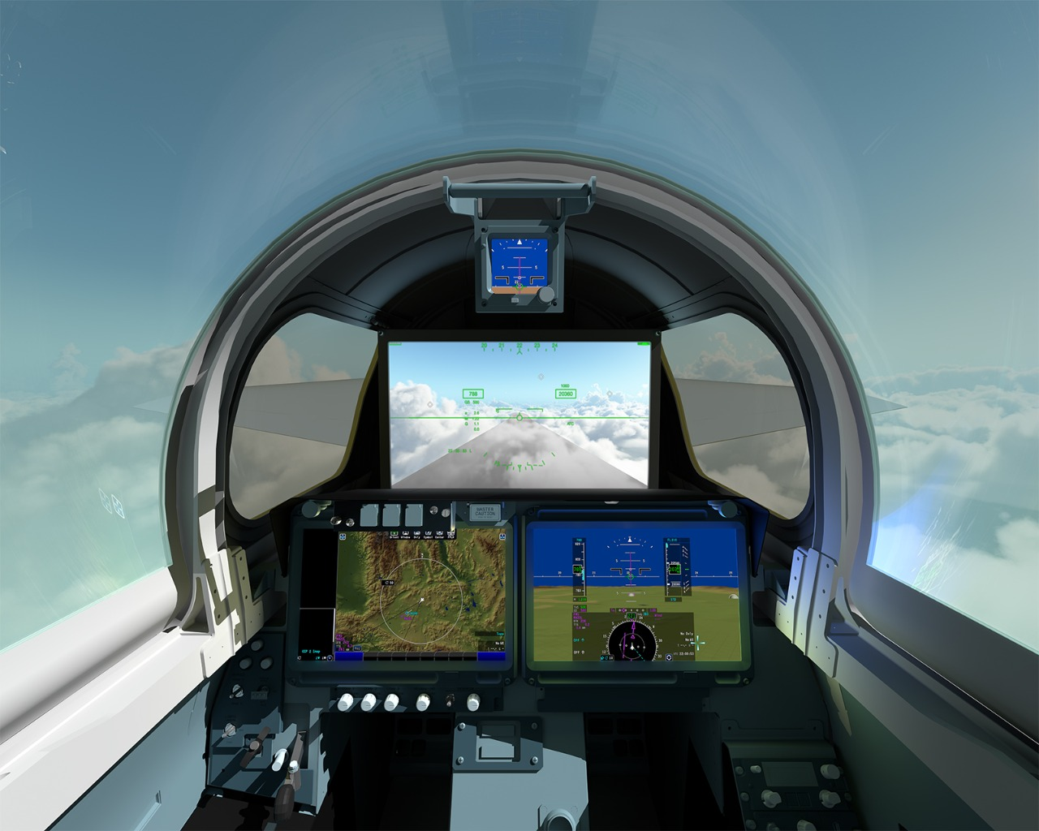

AI is as of now being utilized at air terminals and via carriers for various things. Joined Airlines has tied

up with Amazon Alexa to enable clients to check in and find out about their flights

